

## DOMAIN: CLOUD APPLICATION DEVELOPMENT

## PROJECT NAME: Personal Blogs on IBM Cloud Static Web Apps

**PHASE 2**

**INNOVATION**

In this section you need to put your design into innovation to solve the problem. Create a document around it and share the same for assessment as per the instructions mentioned.

Consider integrating social media sharing buttons, interactive maps, and comment sections to enhance user engagement and interaction.

**INNOVATION:**

**Persona Design:**

* When it comes to persona design, the chatbot is designed with a super technical name, tones and style of replying the questions.
* The chatbot for customer care will be designed as an AI-powered virtual assistant, capable of handling a wide range of customer inquiries and issues.

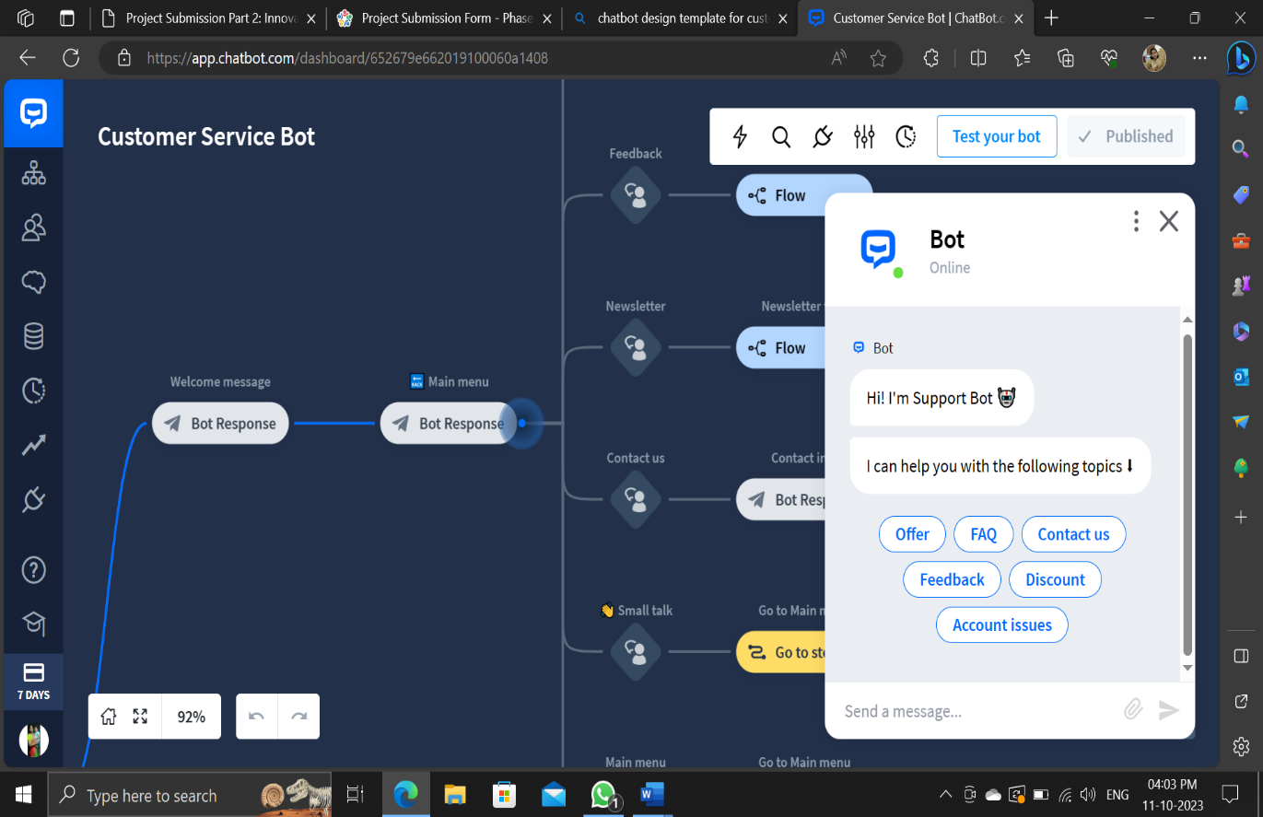

**User Scenarios:**

* It will leverage natural language processing (NLP) and machine learning algorithms to understand and respond to customer queries in a human-like manner.
* Thus, this helps the chatbot to identify the user scenarios and FAQs and answer to them frequently.

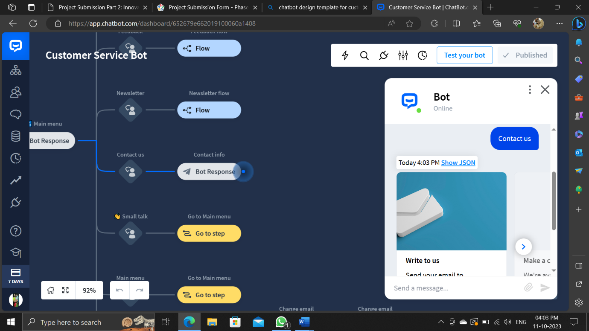

**Platform Integration:**

* For enhancing user’s satisfaction, we build the chatbot with Faster response times, personalized interactions, and 24/7 availability will lead to improved customer satisfaction.
* And integrating the chatbot with popular messaging platforms and developing to fastest responding chatbot for engaging the customers reviews.

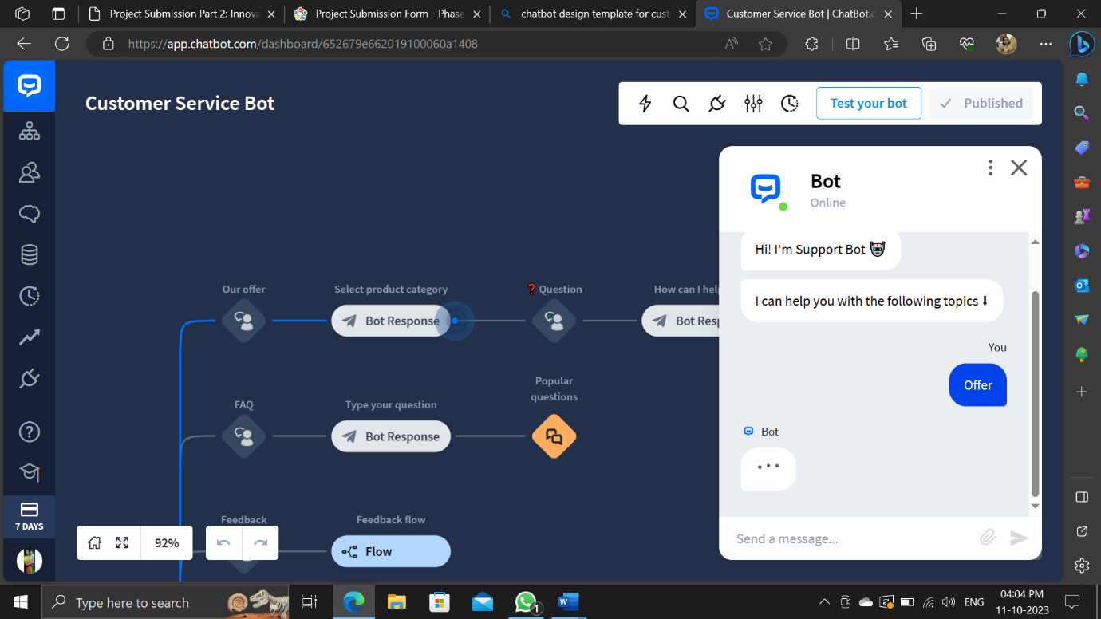

**User Experience:**

* The design will incorporate a user-friendly interface, enabling seamless interactions between customers and the chatbot.
* The chatbot will employ advanced reasoning and decision-making capabilities.
* Customers will receive consistent and accurate responses, eliminating the risk of human errors.
* The chatbot can handle a large volume of inquiries simultaneously, making it highly scalable for growing businesses.

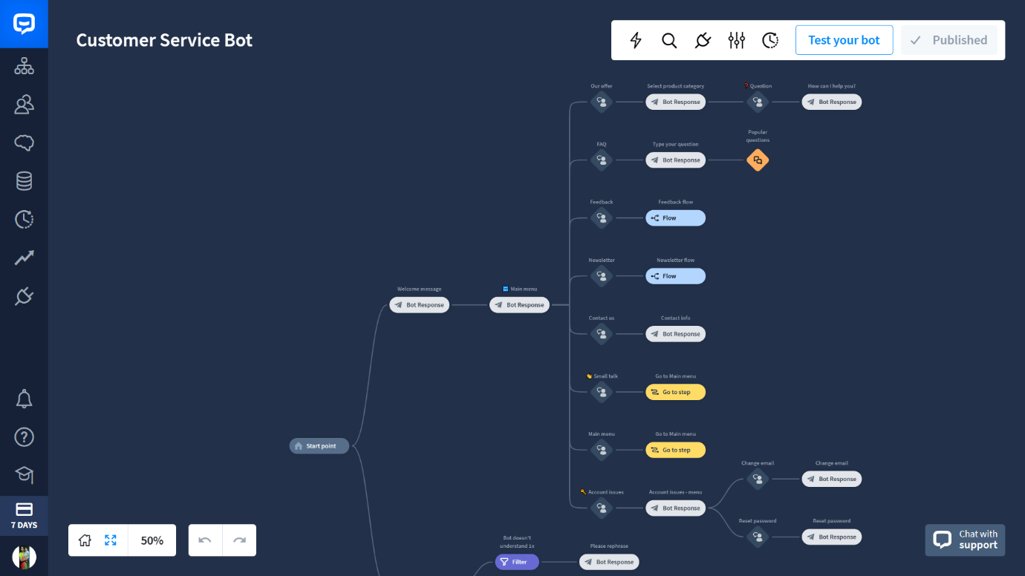

**Conversation Flow:**

* The design will incorporate a user-friendly interface, enabling seamless interactions between customers and the chatbot.
* The chatbot will employ advanced reasoning and decision-making capabilities.
* The chatbot will operate 24/7, reducing response times and allowing businesses to serve customers around the clock that increases the efficiency of usage.

**Response Configuration:**

* The chatbot will analyze customer inquiries, draw from a knowledge base, and use context to provide personalized and relevant responses.
* The IBM Watson Assistant is used with this chatbot to provide virtual customer support and automate responses.

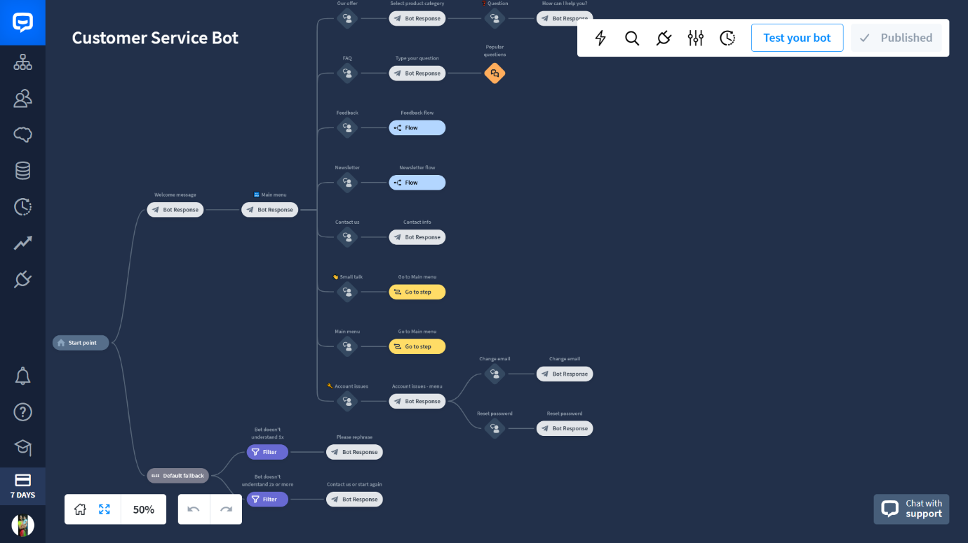

**Problem Definition:**

In today's fast-paced digital age, businesses are faced with the challenge of providing efficient and effective customer support. Traditional customer service channels often lead to long wait times, human errors, and inconsistent responses. This project aims to address these issues by developing a chatbot for customer care.

**Team Members Details:**

|  |  |  |
| --- | --- | --- |
| S.No. | Team Members | Email ID |
| 1 | Amirthasri A | amirthasriarul2324@gmail.com |
| 2 | Janani S | jandharsh@gmail.com |
| 3 | Harini M | Harini662004@gmail.com |
| 4 | Srisubhiksha S | srishaxyz@gmail.com |